

Name: M.Eswarcharan Course Code: ITA0330
Reg No: 192372379 Course Name: Mobile Computing

4 Experiment Name: Mobile Network Protocol Stack Visualization Using Figma

Aim:
To create a visual representation in Figma highlighting the key layers and functions of mobile network protocol stacks.

Procedure

- Open Figma and create a new FigJam board.
- Draw five rectangles and arrange them vertically.
- Label the rectangles as Application Layer, Transport Layer, Network Layer, Data Link Layer, and Physical Layer.
- Add the main functions of each layer below its name.
- Use different colors to distinguish the layers.
- Connect the rectangles using arrows to show the communication flow.
- Align the shapes neatly and save the design.

Output:
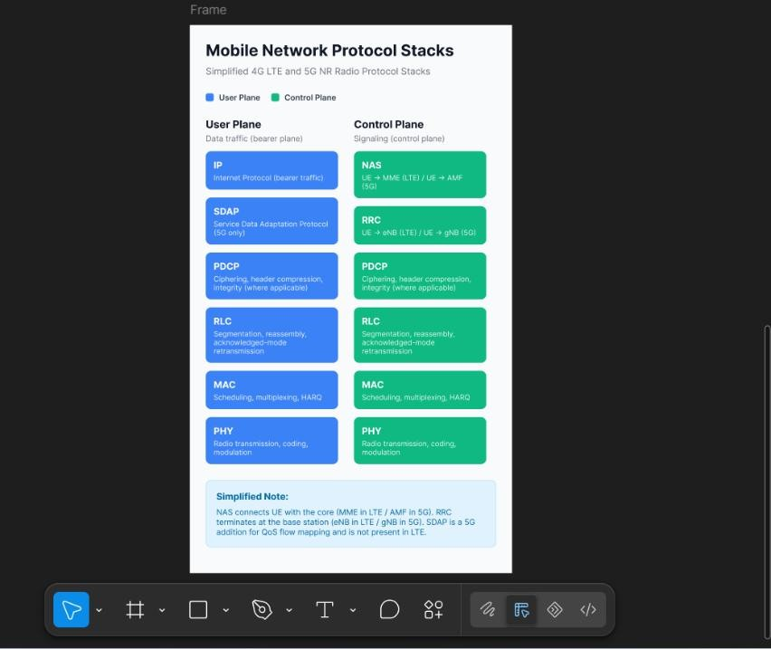

Result:

A visual representation of mobile network protocol stacks was created in Figma, showing the five layers and their main functions in mobile communication.

